**Week 7 Solutions**

**React**

**12. ReactJS-HOL** .

Create a React Application named “ticketbookingapp” where the guest user can browse the page where the flight details are displayed whereas the logged in user only can book tickets.

The code and the folder structure is attached in the **Week 7/** **ticketbookingapp** folder

**Output :-**

**Chrome –** [**http://localhost:3000/**](http://localhost:3000/)

**The Page looks like this :-**



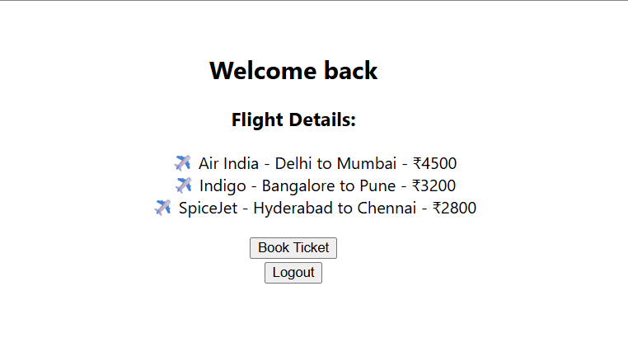

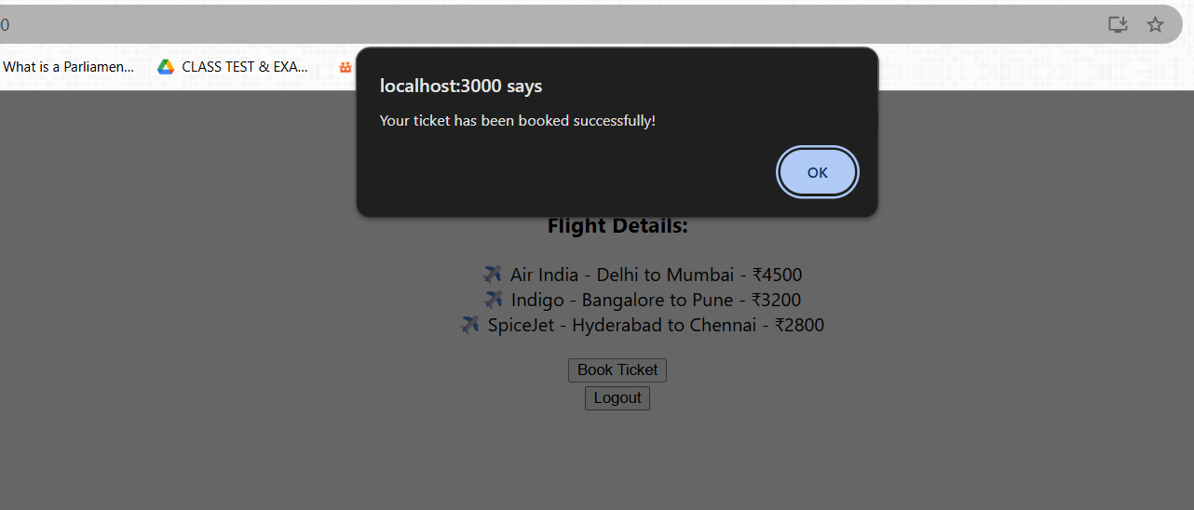

**The hands on file and folder is attached along with it**